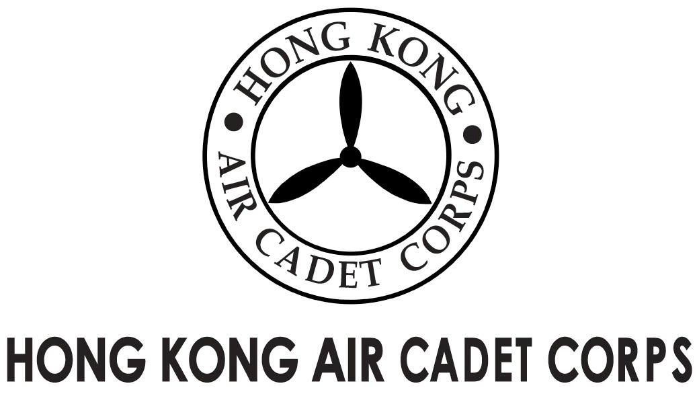
ADMINISTRATION AND SUPPORT GROUP.

From | OC PA Flt  Saki L W LEE  (sakilee0906@gmail.com) | To  Copy to | OC No. 403. No. 408  Major Unit Commanders
Our Ref | GOSA/2018/3 | # of Pages | 1
Date | 17-Dec-2018 | Your Ref

Grantham Uniformed Youth Groups Outstanding Service Award
葛量洪青少年制服團隊傑出服務獎
Nomination Results

Please take note that the Selection Panel has nominated the following cadets to the Secretariat of the Grantham Scholarships Fund for the consideration of the captioned award after reviewing the applications endorsed by OC No.1, 4 Wg.

- FS LEE Hin-yat; and
- Sgt MOK Chun-yiu Jonathan

May I take this opportunity to congratulate FS LEE and Sgt MOK for their successful interviews on behalf of the Selection Panel.

FS LEE and Sgt MOK have impressed the Panel with their excellent service records, passion and caliber. I would like to take this opportunity to wish them every success with their roles in the Corps and in society.

Yours sincerely,

Saki L W LEE
Flying Officer
OC PA Flt

